Sitemap Practical
Creating the SiteMapPath Control : Now lets create an application by using the SiteMapPath control. In this application we design the following three pages:
- The Home Page (Default.aspx)
- The First Page (myweb1.aspx)
- The Second page (myweb2.aspx)
Now we can use the SiteMapPath control using following steps:
Step 1 : Open Microsoft Visual Studio 2010.
Step 2 : Select File->New->Web Site.
Step 3 : Select ASP.NET Web Site and name it as mywebsite.
Step 4 : Add two web forms to the application named myweb1.aspx and myweb2.aspx by performing the following steps:
- Move to the Solution Explorer window
- Right-click on the application name and select the Add New Item option from the context menu
- Name the web form as myweb1.aspx and click the Add button
Step 5 : Similarly add the myweb2.aspx web form to the application. After that we have to add the Site Map file into the project. The Site Map file is the XML file and has the extension .sitemap. The steps are as follows.
Step 6 : Right-click the application in the Solution Explorer window and then click the Add New Item option from the context menu.
Step 7 : Select the Site Map Template from the Templates Pane. Note that, by default, the file has the name web.sitemap.
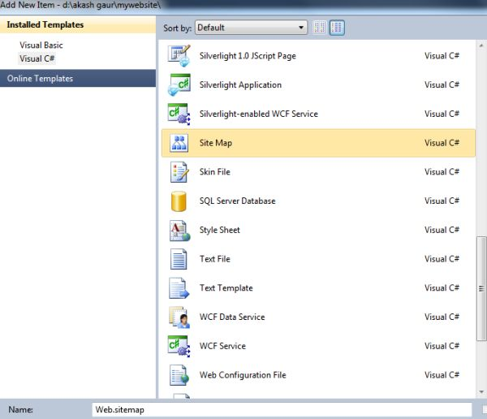
Step 8 : Now click the Add button to add the sitemap file to our application.
Step 9 : Now we can check that the sitemap file has been included in our project and we can see it in the Solution Explorer. And now we have to set the URL and title attributes in the sitemap file.
<?xml version="1.0" encoding="utf-8" ?>
<siteMap xmlns="http://schemas.microsoft.com/AspNet/SiteMap-File-1.0" >
<siteMapNode url="Default.aspx" title="myhomepage" description="">
<siteMapNode url="myweb1.aspx" title="myfirstpage" description="" />
<siteMapNode url="myweb2.aspx" title="mysecondpage" description="" />
</siteMapNode>
</siteMap>
Step 10 : Now Add one SiteMapPath control on the Default.aspx page from the navigation tab of the toolbox.
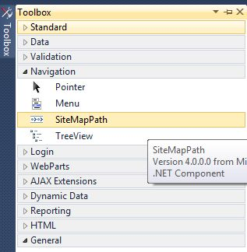
Step 11 : Add three labels and two hyperlink controls from the toolbox to the Default.aspx page and set the text property of the control.
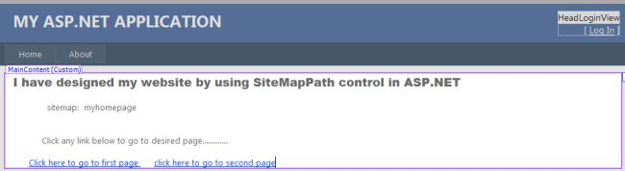
Step 12 : Now set the NavigateUrl property of the first hyperlink control and select the myweb1.aspx file as follows.
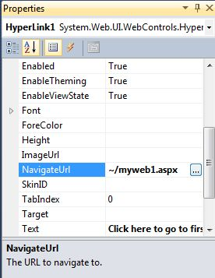
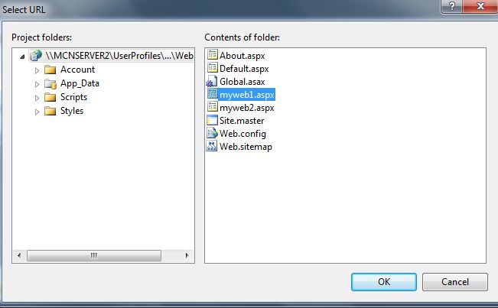
Step 13 : Now set the NavigateUrl Property of second hyperlink control and select myweb2.aspxfile.
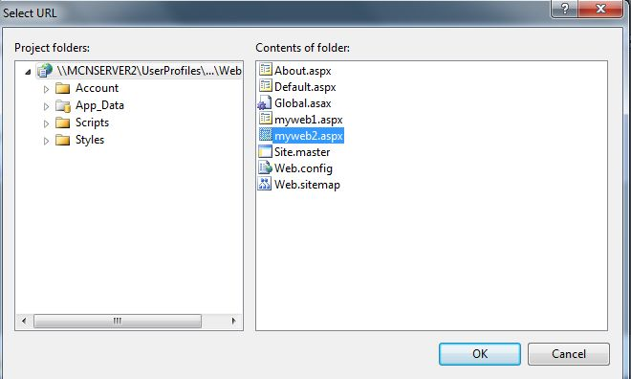
The source code of the Default.aspx page is as follows:
<%@ Page Title="Home Page" Language="C#" MasterPageFile="~/Site.master"AutoEventWireup="true"
CodeFile="Default.aspx.cs" Inherits="_Default" %>
<asp:Content ID="HeaderContent" runat="server" ContentPlaceHolderID="HeadContent">
</asp:Content>
<asp:Content ID="BodyContent" runat="server" ContentPlaceHolderID="MainContent">
<asp:Label ID="Label1" runat="server"
Text="I have designed my website by using SiteMapPath control in ASP.NET"
Font-Bold="True" Font-Names="Arial Black" Font-Size="Large"></asp:Label>
<br />
<br />
<asp:Label ID="Label2" runat="server" Text="sitemap:"></asp:Label>
<asp:SiteMapPath ID="SiteMapPath1" runat="server">
</asp:SiteMapPath>
<br />
<br />
<br />
<asp:Label ID="Label3" runat="server"
Text="Click any link below to go to desired page............."></asp:Label>
<br />
<br /> <asp:HyperLink ID="HyperLink1" runat="server" NavigateUrl="~/myweb1.aspx">Click here to go to first page </asp:HyperLink> <asp:HyperLink ID="HyperLink2" runat="server" NavigateUrl="~/myweb2.aspx">click here to go to second page</asp:HyperLink>
</asp:Content>
Step 14 : Now in the design mode of the myweb1.aspx page, add the same control but add only one hyperlink control and set its NavigateUrl property to myweb2.aspx then click ok.
The source code of the myweb1.aspx page is as follows:
<%@ Page Language="C#" AutoEventWireup="true" CodeFile="myweb1.aspx.cs"Inherits="myweb1" %>
<!DOCTYPE html PUBLIC "-//W3C//DTD XHTML 1.0 Transitional//EN""http://www.w3.org/TR/xhtml1/DTD/xhtml1-transitional.dtd">
<html xmlns="http://www.w3.org/1999/xhtml">
<head runat="server">
<title></title>
</head>
<body>
<form id="form1" runat="server">
<div> <asp:Label ID="Label1" runat="server" Font-Bold="True" Font-Names="Arial Black"
Font-Size="Large"
Text="Thank you for clicking.This is My First Webpage.............."></asp:Label>
<br />
<br />
<asp:Label ID="Label2" runat="server" Text="SiteMap:"></asp:Label>
<asp:SiteMapPath ID="SiteMapPath1" runat="server">
</asp:SiteMapPath>
<br />
<br /> <asp:HyperLink ID="HyperLink1" runat="server" NavigateUrl="~/myweb2.aspx">click here to go to mywebpage2</asp:HyperLink>
</div>
</form>
</body>
</html>
Step 15 : Now in the design mode of the myweb2.aspx page, add the same controls as in myweb1.aspx and set the NavigateUrl property of the hyperlink as Default.aspx then click ok.
The source code of myweb2.aspx is as follows:
<%@ Page Language="C#" AutoEventWireup="true" CodeFile="myweb2.aspx.cs"Inherits="myweb2" %>
<!DOCTYPE html PUBLIC "-//W3C//DTD XHTML 1.0 Transitional//EN""http://www.w3.org/TR/xhtml1/DTD/xhtml1-transitional.dtd">
<html xmlns="http://www.w3.org/1999/xhtml">
<head runat="server">
<title></title>
</head>
<body>
<form id="form1" runat="server">
<div>
<asp:Label ID="Label1" runat="server" Font-Bold="True" Font-Names="Arial Black"
Font-Size="Large"
Text="Thanx for Clicking.This is my Second webpage by using SiteMapPath control.................">
</asp:Label>
</div>
<p>
<asp:Label ID="Label2" runat="server" Text="SiteMap: "></asp:Label>
<asp:SiteMapPath ID="SiteMapPath1" runat="server">
</asp:SiteMapPath>
</p>
<p>&nbsp;</p>
<asp:HyperLink ID="HyperLink1" runat="server" NavigateUrl="~/Default.aspx">Click here to go to Home page</asp:HyperLink>&nbsp;
</p>
</form>
</body>
</html>
Step 16 : Now in the Solution Explorer window, right click on the Default.aspx page and select the Set As Start Page option.
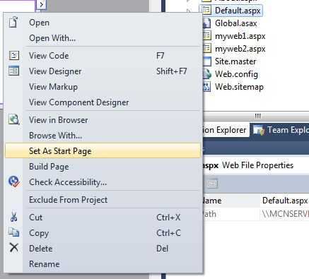
Step 17: Press the F5 key to run the application.
Output :
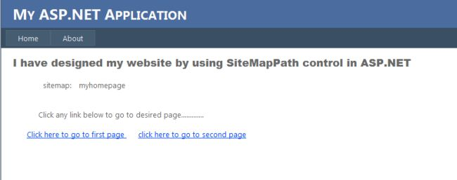
After clicking on the first link the output is as follows.
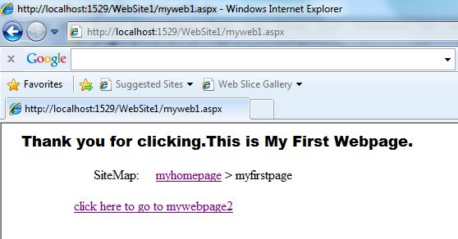
After clicking the link, the output of the second web page is as follows:
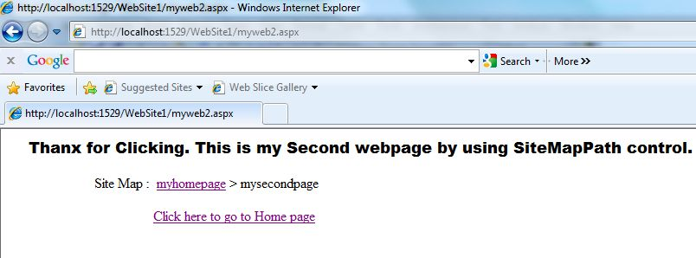
Here are some other useful resources which may help you.

Navigation control

How To Use Navigation Control In ASP.NET
On 03:31:00 By RAMASHANKER VERMA

Navigation controls are very important for websites.Navigation controls are basically used to navigate the user through webpage .It is more helpful for making the navigation of pages easier .There are three controls in ASP.NET ,Which are used for Navigation on the webpage.
- TreeView control
- Menu Control
- SiteMapPath control
There are some Namespaces, which are used for above Navigation controls which are given below:
Using.System.Web.UI.WebControls.TreeView ;
Using.System.Web.UI.WebControls.Menu ;
Using.System.Web.UI.WebControls.SiteMapPath ;

In this tutorial,i will show you ,how to add navigation control on the web page.I will also give you real example of each control.Please read each control very carefully and use it on ASP.NET website.You can download each controlapplication from bottom and implement on your system.

1. ) The TreeView Control:-
The TreeView control is used for logically displaying the data in a hierarchical structure.We can use this navigation control for displaying the files and folders on the webpage.W can easily display the XML document,Web.SiteMap files and Database records in a tree structure.
There are some types to generate navigation on webpage through TreeView control.
- TreeView Node Editor dialog box
- Generate TreeView based on XML Data
- Generate TreeView based on Web.SiteMap data
- Generate TreeView from Database.

1.1) TreeView Node Editor Dialog Box:-
There are some steps to generate the Tree structure on the page,which are given below:
Step 1: First open your visual studio-->File-->New-->Website-->Select ASP.NET Empty Website -->OK-->open solution explorer-->Add New Web Form-->Drag and Drop TreeView control from Toolbox as sown below:
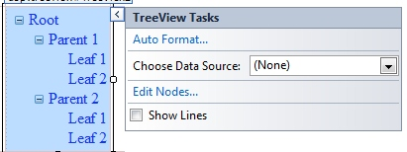

Step 2: Now go properties of TreeView control-->Click Nodes-->Add Root and child Node as shown below:
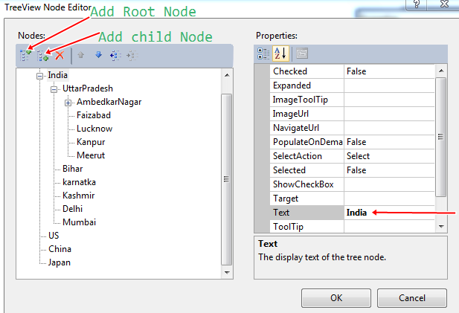

Step 3: Now Run the Program(press F5).
output:
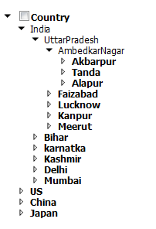

1.2 ) Generate TreeView Based On XML Data:-

There Are Some Steps To Implement This Concepts On The Webpage,Which Are Given Below:

Step 1: Now First Add A Web Form And A XML File In Your Solution Explorer-->Now Open The XML File And Write The Following Codes As Shown Below-->Now Click Save.
<?xml version="1.0" encoding="utf-8" ?>
<application>
<homepage title="Country" value="default.aspx">
<page title ="INDIA" value="default.aspx">
<subpage title ="up" value="default.aspx"/>
<subpage title ="delhi" value="default.aspx"/>
<subpage title ="mumbai" value="default.aspx"/>
<subpage title ="kolkata" value="default.aspx"/>
</page>
<page title ="US" value="default.aspx"/>
<page title ="CHNIA" value="default.aspx"/>
<page title ="JAPAN" value="default.aspx"/>
</homepage>
</application>

Step 2:Now Drag and drop TreeView control on the Web Form --> Now Choose Data Source from TreeView control-->Select New data source as shown below:

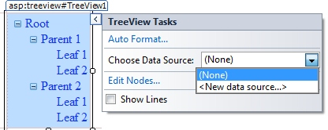
Step 3:Now select XML File as shown below:-->OK.
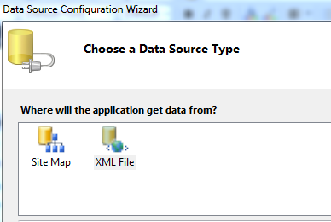
Step 4: Now Browse your XML File as shown below-->OK
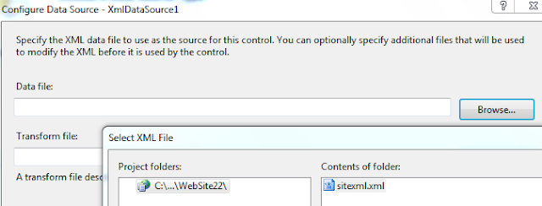
Step 5: Now click Edit TreeNode DataBindings..-->Select each page one by one -->and click Add button -->setTextField =title from right side for each page-->click Apply as sown below:
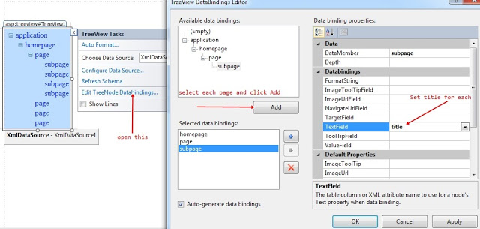
Step 6: Now Run the program(press F5).
Output:
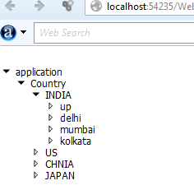

1.3 ) Generate TreeView Based On Sitemap Data:-
Step 1: First Add a Web Form and a SiteMap in Solution Explorer as shown below-->Add
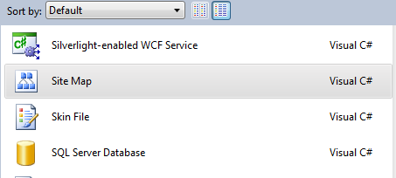

Step 2: Open web.sitemap file and write the following codes.which are given below-->Save
<?xml version="1.0" encoding="utf-8" ?>
<siteMap xmlns="http://schemas.microsoft.com/AspNet/SiteMap-File-1.0" >
<siteMapNode url="default.aspx" title="Contury" description="">
<siteMapNode url="treeview1.aspx" title="India" description="" />
<siteMapNode url="menu.aspx" title="Us" description="" />
<siteMapNode url="menu1.aspx" title="China" description="" />
</siteMapNode>
</siteMap>

Step 3: Now drag and drop TreeView control on the Form-->Now choose Data Source-->select New data source-->Select SiteMap as sown below:
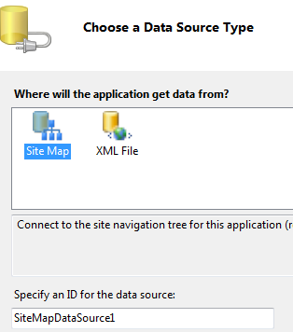
Step 4:Now click OK Button ,you will see following output.
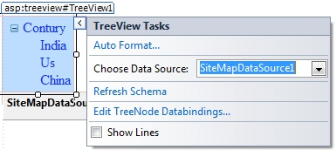
Step 5: Now Run the program(press F5).
OUTPUT:
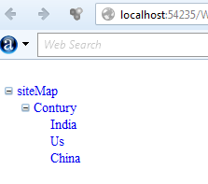

2. ) The Menu Control:-
The menu control is a Navigation control,which is used to display the site navigation information .This can be used to display the site data structure vertically and horizontally.It can be used a binding control as TreeView control.Means we can easily bind the XML and SiteMap data in menu control.
The menu control can be used as two types.
- Static menu:- It is used to display the parent menu items and their sub menu items on the page.Means it is used to display the entire structure of the static menu.
- Dynamic menu:- It is used to display the static menu as well as dynamic menu on the site.it Means when user passes the mouse over the menu then it will appear on the site.

2.1 ) Static Menu:-
We can display site structure vertically as well as horizontally through static menu control on the site.There are some steps to implement the static menu control on the Web Form.Which are given below:Step 1: First Add a New Web Form in solution Explorer -->drag and drop menu control on the Form-->now select Views = static as shown below:
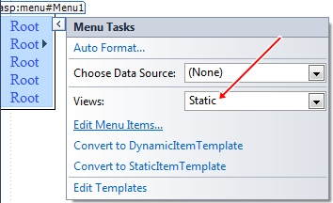

Step 2: Now click Edit Menu Items...-->Add parent and child nodes as shown below:
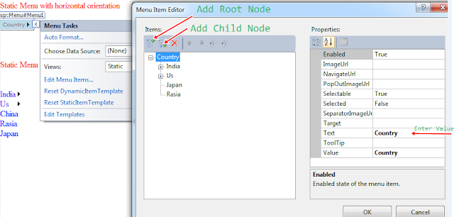
Step 3: Now Run the program(press F5).
Output:-
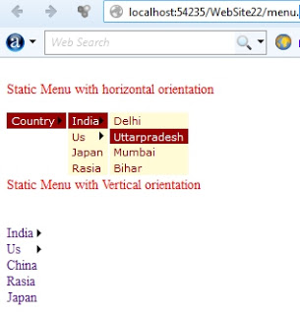
Note:- You can implement the vertical orientation as horizontal orientation.

2.2 ) Dynamic Menu:-
When user passes the mouse over the control ,the data will automatically appear on the site.we can generate dynamic menu control in two ways:
- Generate menu control using Xml Data source
- Generate menu control using SiteMap Data source
There are some steps to implement this concepts on the site.which are given below:-
Step 1: First Add a Web Form in the solution Explorer-->Drag and drop menu control on the Form -->choose Data Source -->Select XML File-->OK-->Browse XML File-->OK.
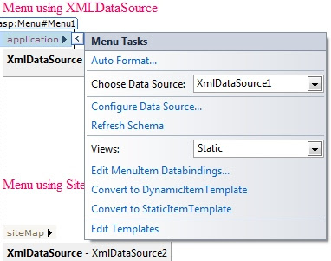
Step 2: Now click Edit TreeNode DataBindings..-->Select each page one by one -->and click Add button -->set TextField =title from right side for each page-->click Apply as sown below:
Step 3: Now Run the program(press F5).
Output:-
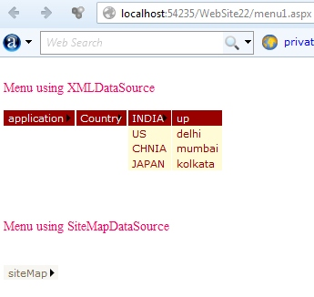
Note:- We can use same process for SiteMap File also.

3. ) The SiteMapPath Control:
The SiteMapPath control is also used to display the Navigation information on the site.It display the current page's context within the entire structure of a website.
There are some steps to implement the SiteMapPath control on the web page.Which are given below:
Step 1: First open your visual studio -->File -->New-->Website-->Select ASP.NET Empty Website-->Opensolution Explorer-->Add a Web Form (SiteMap.aspx)-->Now again Add Site Map File in solution Explorer-->open web.sitmap file-->write the following codes , which are given below:
<?xml version="1.0" encoding="utf-8" ?>
<siteMap xmlns="http://schemas.microsoft.com/AspNet/SiteMap-File-1.0" >
<siteMapNode url="SiteMap.aspx" title="Country" description="">
<siteMapNode url="page1.aspx" title="India" description="" />
<siteMapNode url="page2.aspx" title="China" description="" />
<siteMapNode url="page3.aspx" title="US" description="" />
</siteMapNode>
</siteMap>

Step 2:Now drag and drop SiteMapPath control on the web Form (SiteMap.aspx)-->Now drag and dropHyperLink control on the Form as shown below:
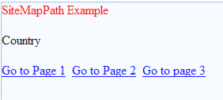
Step 3: Now Add three more Web Form (page1.aspx ,page2.aspx, page3.aspx) in Solution Explorer-->Goproperties of HyperLink Button control -->set NavigateUrl-->Write Text Information ,as shown below:
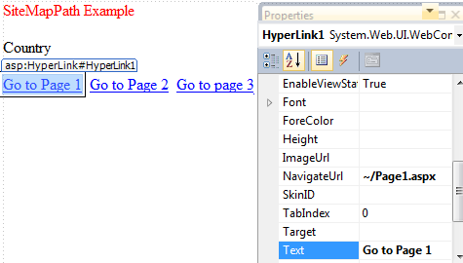
Step 4: Now Go page1.aspx -->drag and drop SiteMapPath control and HyperLink control on the Form as shown below-->Set the NavigateUrl of each HyperLink control as previous i have done.
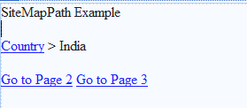
Step 5: Now Go page2.aspx -->Same steps perform as step 4.

Step 6: Now Go page3.aspx -->Same steps perform as step 4 and step 5.
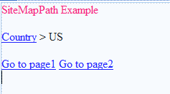
Step 7: Now Run the program(press F5).
Output:-
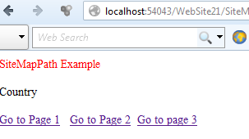
Note:-Download Whole application from bottom and Run it on your system.
For More:-
- Web Form control (I)
- Web Form control (II)
- Create Setup File with .mdf Database
- Host ASP.NET application on server Free
- Ado.Net Application
- How to use secure login page in asp.net with example
- How to Add and verify Captcha image in 3 tier architecture in asp.net
- How to use virtual keyboard in asp.net for security purpose
- How to implement hashing concepts in asp.net
- Learn complete .Net Interview Questions and answers for job seekers

PRACTICAL NO. : 06(1)
AIM: Database programs with ASP.NET and ADO.NET.
Create a Web App to display all the Empname and Deptid of the employee from the database using SQL source control and bind it to GridView . Database fields are(DeptId, DeptName, EmpName, Salary).
Steps:
1. File→new→website→empty website→name it→ok
2. Right click on website made→add new item→sql server database→name it→add→yes
3. Right click on table In server explorer→add new table→add columns→save the table
4. Right click on table made →show table data→add values
5. Right click on website→add new item→webform→name it
6. Go to design view
7. Add a gridview→below that add sqldatasource
8. Configure sqldatasource→then add it to the gridview
9. Go to gridview menu enable sorting

DESIGN:

OUTPUT:
PRACTICAL NO. : 06(2)
AIM: Database programs with ASP.NET and ADO.NET
Create a Login Module which adds Username and Password in the database. Username in the database should be a primary key.
Steps2:
1. File→new→website→empty website→name it→ok
2. Right click on website made→add new item→sql server database→name it→add→yes
3. Right click on table In server explorer→add new table→add columns→save the table
4. Right click on table made →show table data→add values
5. Right click on website→add new item→webform→name it
6. Go to design view→add form for login
7. Add sqldatasource→configure it
8. Write code

DESIGN:
CODE:
LoginModule.aspx
using System;
using System.Collections.Generic;
using System.Linq;
using System.Web;
using System.Web.UI;
using System.Web.UI.WebControls;
public partial class LoginModule : System.Web.UI.Page
{
protected void Page_Load(object sender, EventArgs e)
{
}
protected void btnSignUp_Click(object sender, EventArgs e)
{
SqlDataSource1.InsertParameters["Username"].DefaultValue = txtUserName.Text;
SqlDataSource1.InsertParameters["Password"].DefaultValue = txtPassword.Text;
SqlDataSource1.Insert();
lblResult.Text = "User Added";
}
}
OUTPUT:

PRACTICAL NO. : 06(3)
AIM: Database programs with ASP.NET and ADO.NET
Create a web application to insert 3 records inside the SQL database table having following fields( DeptId, DeptName, EmpName, Salary). Update the salary for any one employee and increment it to 15% of the present salary. Perform delete operation on 1 row of the database table.
Steps:
9. File→new→website→empty website→name it→ok
10. Right click on website made→add new item→sql server database→name it→add→yes
11. Right click on table In server explorer→add new table→add columns→save the table
12. Right click on table made →show table data→add values
13. Right click on website→add new item→webform→name it
14. Go to design view→add necessary form
15. Add a grid view below the form→below that add sqldatasource
16. Configure sqldatasource→then add it to the gridview
17. Go to grid view menu→add columns→select command field→check on delete and edit→ok

10.Double click on button→write code.
DESIGN:
CODE:
using System;
using System.Collections.Generic;
using System.Linq;
using System.Web;
using System.Web.UI;
using System.Web.UI.WebControls;
public partial class LoginModule : System.Web.UI.Page
{
protected void Page_Load(object sender, EventArgs e)
{
}
protected void btnSignUp_Click(object sender, EventArgs e)
{
SqlDataSource1.InsertParameters["Username"].DefaultValue = txtUserName.Text;
SqlDataSource1.InsertParameters["Password"].DefaultValue = txtPassword.Text;
SqlDataSource1.Insert();
Textbox1.Text=”’;
Textbox2.Text=”’;
}
}
OUTPUT:

